Flake Tools Old Stone Age

Espinosa Ranch Site, Cagayan
16000-8000 BC

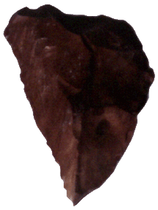
Early man fashioned implements for survival from stones he found in the riverbeds. Flake tools and cobble tools were the earliest implements he made during the Palaeolithic (or Old Stone Age) Period. He used these tools as knives and scrapers.
The proof of earliest man’s presence was recovered from a ranch site in Cagayan Province-two flake tools dated about .9 million years, the oldest man-made object associated with the fossils of a proboscidean, a prehistoric elephant.
Flake tools are stone implements made by ancient man during the Paleolithic Age until the Early Metal Age. The stone tool is produced by striking the core of a stone with a stone hammer (direct percussion) or by using a stone hammer with bone or wood as an intermediate object between the hammer and the potential stone tool (indirect percussion). By means of indirect percussion, the toolmaker can control the size and the shape of each chip. A flake can also be made by using pressure. The toolmaker pushes or pries small flakes from the surface of the stone tool using a piece of wood or bone. This method results in precise flaking and the creation of fine, sharp-edged tools. Flake tools fashioned by ancient Filipinos were used as knives, scrapers and other implements.
Many of the flake tools recovered in Tabon Caves, Palawan were made from chert, a hard stone commonly found in the nearby riverbeds of Quezon, Palawan. Flake tools used during the Palaeolithic Age dated 16,000-8,000 B.C.were found in Laurente Cave in Penablanca, Cagayan. Stone tools were also unearthed in Bolobok Cave, Sanga-Sanga in Tawi-Tawi (southern Philippines) and from other sites in Penablanca, Cagayan (northern Philippines) such as Musang Cave, Callao Cave and Rabel Cave. Up to the Early Metal Age, flake tools were still used as evidenced by the recovery of a stone tool in Pintu Cave, Isabela.

Skull-cap Old Stone Age

Tabon Cave, Quezon Palawan
14500 BC

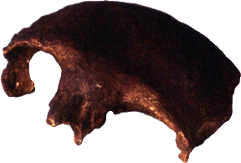
One of the earliest human remains in the archipelago is a fossilized skull-cap (frontal bone) that belongs to a female estimated to be 22,000 years old. It was discovered together with a right mandible (jaw) and teeth in Tabon Cave, Palawan by Robert Fox of The National Museum.
These fossils of modern man (Homo sapiens sapiens) were recently dated using the new direct dating methods. The skull-cap is now dated to 16,500 years (14,500 B.C.) and the mandible to 31,000 years (29,000 B.C.). The oldest human fossil recovered by the National Museum during the re-excavation of the Tabon Cave is a tibia (bone of the lower leg) that dates back to 47,000 years (45,000 B.C.).
Stone and Shell Adzes New Stone Age

Cagayan, Palawan, Isabela, and Pampanga
~2680 BC

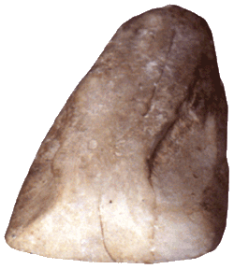
Prehistoric man used ground and polished stone tools. It is believed that a stone adze shaped like an upper front incisor could be found where lightning hit a tree. Today, these stone implements are associated with thunder and lightning. Locally they are called ngipe’t duldug (thunder tooth), tango han linti (lightning tooth), and dila latik (light-ning tongue).
The polished stone adzes that are oval in cross-section were made and used by the people during the Early Neolithic period. Ground stone tools typical of the ‘Quadrangular Adze Culture’ on the other hand, were found in a late Neolithic jar burial site. They are believed to be used for woodworking. These are small, ground and polished adzes of fine grained stones which are rectangular or trapezoidal in cross-section.
The stone adzes were found in Arku Cave, in Penablanca, Cagayan; Duyung Cave in Palawan; Dimolit, Isabela; and Candaba, Pampanga.
In places where stones were not available, shells were used to make tools. Shell adzes were fashioned from hinges of giant clams (Tridacna gigas and Tridacna maxima) and polished into different shapes. Shell adzes found in Duyong Cave, Palawan were dated 2680 B.C. Shell tools were also found in Balobok rock shelter, Sanga-Sanga, Tawi-Tawi; and in Bato Cave, Sorsogon. Those recovered in Palawan and Sanga-Sanga, Tawi-Tawi were similar to those in the Pacific specially Micronesia and Ryukyu group of islands and in Okinawa, Southern Japan. The use of polished stone tools persisted until the Metal Age. Stone implements used during the Metal Age were recovered from other sites namely Manga Site, in Andarayan and Lal-lo, Cagayan.
Shell Bracelets and Pendants New Stone Age

Cagayan, Palawan, and Sorsogon
4854 BC

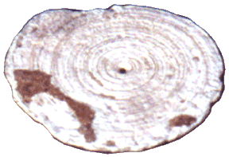
In the early days, shells were fashioned into tools, as well as ornaments. The oldest known ornaments made from cone shells were found in the early 1960’s in the grave of an adult male in Duyong Cave in Palawan. A shell disk with a hole in the center was found next to his right ear and a disk with a hole by the edge was found on his chest. The shell ornaments were dated 4854 B.C.
Other personal ornaments such as earrings, anklets, bracelets and beads recovered from grave sites were found together with spoons, dippers and other tools fashioned from shells. Shell beads recovered from other sites were made from cowry, whelk, and conch shells. Shell beads were also recovered from Arku Cave in Cagayan, Ngipe’t Duldug Cave in Palawan and in Bato Caves, in Sorsogon; a shell bracelet was also found in Bato Caves.
The shells of giant clams were fashioned into large spherical beads with holes drilled end to end at the center while pendants for the ear were ground from cone shells. Perforations were drilled at the center of the disk. Bracelets and anklets were both made from giant clams and cone shells. Shell bracelets made from the top shoulder of the body whorls of cone shells (Conus litteratus) are characteristic of the Late Neolithic Age. The natural spiral found along the shoulders of the shell serves as a decorative motif. Shell bracelets were recovered in Duyong Cave and Leta-Leta Cave in Palawan.
Up to the Metal Age, shells were the major material for the manufacture of both tools and ornaments but shell technology attained its highest development during the Neolithic Period.
At present, the people of Palawan living near Tabon Caves still fashion bracelets from shells. The boring and polishing of the shell ornaments is done with stone tools.
Angono Petroglyphs New Stone Age

Angono, Rizal
2000 BC


The earliest prehistoric rock drawings studied extensively were those found at the boundary ofAngono and Binangonan, Rizal Province. The site is a rock shelter or a shallow cave about 63 meters wide, 8 meters deep and 5 meters at its highest point. One hundred twenty seven human figures scattered on the wall were made by engraving lines using a piece of stone on the surface of the rock shelter. The cuts vary from ten centimeters down to faint lines figures. The figures consist of circular heads, with or without necks set on a rectangular or v-shaped body. The linear arms and legs are usually flexed. Some incisions on the rock wall are triangles, rectangles and circles. Rock art is closely linked with a system of belief of a particular group of people. It is symbolic, not decorative.
Rock art in the Philippines is rare. Samples of these drawings were reported in places such as Penablanca Caves in Cagayan Valley; rock outcroppings in Alab, Bontoc, Mt. Province; and caves in Singnapan Basin in Ransang, Palawan.
Bark-Cloth Beater New Stone Age

Arku Cave, Peñablanca, Cagayan
1255-605 BC

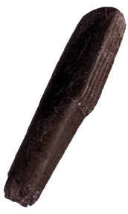

It is a stone tool used for the preparation of bark cloth. Early man in Palawan fashioned the beaters from cylindrical stones and used the stone beaters for pounding the bark to loosen the pulp from the fiber. The bark cloth is ready when all the pulp has been stripped off, leaving a network of fibers. The stone tool found in Arku Cave, Penablanca, Cagayan was dated 1255-605 B.C. Another bark-cloth beater was found in Sagung cave in Southern Palawan.

Manunggul Jar New Stone Age

Manunggul Cave, Lipuun Pt., Palawan
895-775 BC

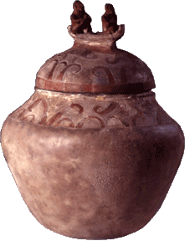

The cultural treasure found in the early 1960’s in Manunggul Cave, Lipuun Point, Palawan is a secondary burial jar. The upper portion of the jar, as well as the cover is incised with curvilinear scroll designs and painted with natural iron or hematite. On top of the jar cover or lid is a boat with two human figures representing two souls on a voyage to the afterlife. The boatman is seated behind a figure whose hands are crossed on the chest. The position of the hands is a traditional Filipino practice observed when arranging the corpse.
The burial jar which is unrivaled in Southeast Asia and considered as the work of a master potter, signifies the belief of early Filipinos in life after death. It is dated to the late Neolithic Period, about 890-710 B.C.
Banton Cloth Age of Contact

Banton Is., Romblon
1400 - 1500 AD

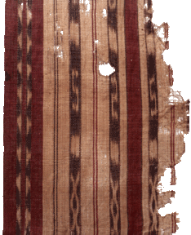

The Banton cloth is the earliest known warp ikat (tie-resist dyeing) textile in Southeast Asia. Estimated to be 400 years old, the burial cloth was found in a wooden coffin that also contained blue and white ceramics in Banton Island, Romblon. The shroud was woven from red, black and white abaca threads. At present, the people in Bontok, Mt. Province use a colorful burial cloth to wrap the dead.
The process of weaving is simple. The threads are measured and wound on a frame. These are wrapped in a pattern with a wax string or a strip of vine and then dyed. As soon as the threads are dry, these are set up on a loom for the weaving.
Gold Death-Mask Age of Contact

Oton, Iloilo
1300 - 1400 AD

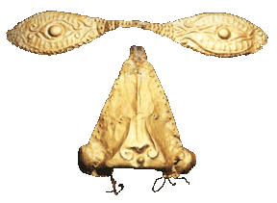
Long before the coming of the Spaniards, early inhabitants used gold ornaments for the the dead. The face of the corpse was covered with delicately worked sheets of gold. The craftsman cut out two pieces. He placed the first piece on a soft surface like clay or wax and with a pointed tool, pressed the design from behind.He used a different design for each eye. He shaped the second sheet for covering the nose.
The burial practice of covering the eyes, nose and mouth of the dead with sheets of gold is a custom of the southern Chinese practiced by a limited group of Filipinos. It is believed that when the face of the dead is covered with a gold mask, evil spirits cannot enter the body. The gold nose-disc and gold eye-mask dated from the late 14th to the early 15th century A.D. was found in a grave site in San Antonio, Oton, Iloilo (Central Philippines). Aside from the museum collection, another pre-hispanic gold burial mask was also recovered in Masao, Butuan, Agusan del Norte where gold was abundant in ancient times.
Butuan Boat Metal Age

Libertad, Butuan City
320 AD

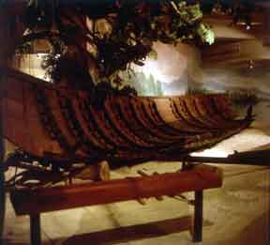
Prehistoric boats were recovered in Butuan, Agusan del Norte in 1978. There are nine existing prehistoric boats. The first boat dated 320 A.D. is in the site museum in Libertad, Butuan. The second boat dated to 1250 A.D. was transferred to the Pinagmulan Gallery (The Origin), in the 2nd floor of the Museum of the Filipino People in Manila. The third boat dated 990 A.D. is in theButuan Regional Museum (Agusan del Norte, southern Philippines).
The Butuan boat is an edged- pegged plank type of boat. The planks were made from hard wood like ‘doongon’ (Heriteriera littoralis). Built to withstand long-distance voyages, the boat can seat 25 people. Early merchants purchased goods from foreign traders and sailed the small waterways redistributing the commodities to remote communities in the archipelago. The presence of glass beads and metals in the sites where the boats were discovered shows that Philippine coastal communities were active in Asian maritime trade during that time. Evidence of a flourishing maritime trade placed the early Filipinos’ seamanship and boat- building skill on equal footing with other Asian countries.
The edged-pegged plank style of boat-building was once popular from Scandinavian countries to the South Pacific during the 3rd century. Present- day boat makers of Sibutu Island and in southern Philippines still use the same technology.

