Ifugao Blanket
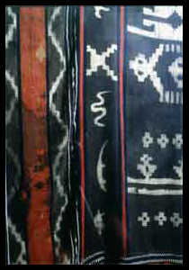
The kinuttiyan or a cotton blanket is a rare ethnographic textile collection of the Anthropology Division. There are only a few existing kinuttiyan documented and they are found in the municipalities of Banaue, Kiangan and Hungduan in Ifugao Province. The blanket is woven by women using the back strap loom. It is made and formed from commercialized cotton threads, utilizing the tie and dye method from natural dyes (ikat technique). Indigenous plants locally called hawili (Elaecarpus pendulus) and bolux (Acalypha stipulacea klotz) is mixed and boiled until the desired black color is achieved. This is also done to other indigenous legumes for the red and yellow colors. The red and yellow colors are utilized for aesthetic purposes.
The blanket has anthropomorphic figures at the center. It was used to cover the corpse of an Ifugao after death. The blanket is a national cultural treasure collected in June 13, 1968 by William Beyer in the municipality of Amganad, Banaue, Ifugao.
The blanket is 2.68 meters in length and 1.92 meters in width.
Syllabic
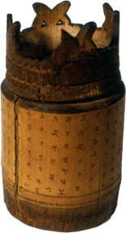
Writing is an ancient form of communication in the Philippines. Reading and writing had spread through the archipelago via the complex network of trade routes. Early Filipinos wrote on bamboo segments, tree barks and palm leaves with pointed knives, sticks and charcoal in the place of modern day paper and pen. Traditionally, writing was used for the expression of poetry and personal letters.
Generally, there are 17 symbols in the Philippine syllabary or which 14 represent consonant and 3 represent vowels. The consonants are ba, ka, da, ha, la, ma, na, nga, pa, sa, ta, wa and ya. The addition of ra in some groups is recent adaptation. A diacritical mark above the consonant represents the “i/e” sound, while a diacritical mark below represents the “o/u.” Of the various writing systems derivative of the baybayin, only four ethnolinguistic groups have retained the use of the ancient syllabic scripts; the Hanunoo and Buhid of Mangyan in Mindoro and the Tagbanua and Pala’wan of Palawan. However, they are on the verge of losing their own writing because of cultural and environmental pressures, therefore steps have been taken to prevent their extinction. Antoon Postma, a former SVD missionary Dutch and later married one of the local Mangyan, worked to revive the Hanunoo script and established a school for this purpose. The National Museum has also started a project that aims to revive the use of the Buhid, Tagbanua and Pala’wan system of writing.
Maranao Drum (Tabu)
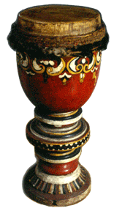

The Maranao tabu or drum is made of a carved wood with floral motif all over the body and lies on a carved wooden stand. It has a three-layered base with a carved pako (fern motif) and kianako (fingernail like) motif. The drum is used inside the mosque for calling the faithful for prayer, and symbolizes the gathering of the Muslims to observe their religious obligation.
The drum is 2.90 meters in height and has a diameter of 0.50 meters. It is a rare drum and a significant collection to the Anthropology Division because of its extra-ordinary in size that is seldom seen in Muslim mosque today. The tabu is rarely manufactured today, as there are few carvers among the Maranao. They are more on brass making technology today.
Maranao kulintangan and korsi
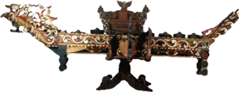
The Maranao korsi is a carved wooden chair with a carved niaga (fern) motif in front and an eagle on top of the backrest. This chair was collected by Datu Natancup in Lanao del Sur in August 28, 1962 and is considered as a cultural treasure because of its unique traditional Maranao okir designs. The korsi is rarely manufactured today and is basically used as a seat for the kulingtangan player.
Together with the korsi the kulingtang (xylophone) is also a cultural treasure. It is a Maranao musical instrument with 8 graduated gongs. One end has three red and orange niaga motif while the other end has the sarimanok motif. These motifs symbolize Maranao traditional designs that are combined to produce intricate abstract motif in the form of animals, plant part or any common object. These motifs are referred to as okir, which literally means to carve.
Lepa Boat
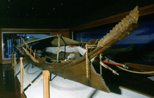
The lepa boat is a houseboat of the Sama D’Laut better known as the Badjau. They are the sea faring or “sea gypsies people” located in Sitangkai, Tawi-tawi and Bongao. They use their houseboat to travel from one place to another and fish along the way for their subsistence. They are a mobile people reaching as far as Sulawesi, Indonesia, Sabah and even Vietnam. The houseboat is one of the most beautiful of traditional boats possessing an ancient type of architecture that has a uniquely designed sail. It is made of hardwood most probably the yakal tree with carvings (okil) directly on the boat, projecting hulls and prow. This was collected in Sitangkai, Tawi-tawi from the Japan Foundation grant. The boat is 10.7 meters long; 1.8 m width and 1.6 meters in height, and was built along the shores of Sitangki among the Sama D’Laut boat builders.
The houseboat is decked and provided with a living quarter covered by a plaited nipa roof that is detachable. The family’s food and water storage areas are located near the stern where meals are prepared. Inside the lepa boat are household items like cooking pots, coconut shell ladles, water jug and other fishing tools and implements. This is presently exhibited in Fort Pilar, Zamboanga NM Branch.
Sama Grave Marker
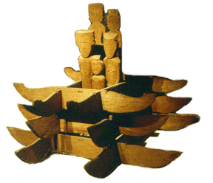

The Sama D’Laut are sea faring people but they bury their dead in land. They mark their graves with stylized human figures that indicate the gender and age of the deceased. The grave markers of the Sama D’laut are silent sentinels of the afterworld. Grave markers consist of an upright piece of wood called sundok. This is placed over the head of the deceased and in front of the sunduk is a raised mound of earth or sand, and a rectangular frame called the kabul that surrounds the entire site. Sea cow figures are commonly carved into wooden markers along with crocodiles, birds and human figures. Sometimes sundoks are inserted into a base formed into a sea cow, boat, box, or some other animals. These motifs are representative of the Sama belief in the transportation of the spirit to the next life.
Tagakaolo Upper Garment
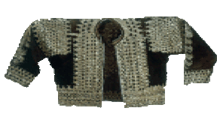
Tagakaolo upper garment made of abaca (Musa textilis) cloth decorated with mother-of-pearl platelets. This is worn among the Tagakaolo men for special occasion.
O.V. Wood collected the upper garment in the early 20th century in Sta. Cruz, Davao, and is 0,38 meters in length.

