Spoliarium
19th Century
Juan Luna

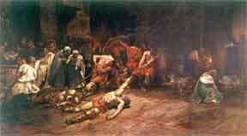
The painting features a glimpse of Roman history centered on the bloody carnage brought by gladiatorial matches. Spoliarium is a Latin word referring to the basement of the Roman Colosseum where the fallen and dying gladiators are dumped and devoid of their worldly possessions.
At the center of Luna’s painting are fallen gladiators being dragged by Roman soldiers. On the left, spectators ardently await their chance to strip off the combatants of their metal helmets and other armory. In contrast with the charged emotions featured on the left, the right side meanwhile presents a somber mood. An old man carries a torch perhaps searching for his son while a woman weeps the death of her loved one.
The Spoliarium is the most valuable oil-on-canvas painting by Juan Luna, a Filipino educated at the Academia de Dibujo y Pintura (Philippines) and at the Academia de San Fernando in Madrid, Spain. With a size of 4.22 meters x 7.675 meters, it is the largest painting in the Philippines. A historical painting, it was made by Luna in 1884 as an entry to the prestigious Exposicion de Bellas Artes (Madrid Art Exposition, May 1884) and eventually won for him the First Gold Medal.

Burning of Sto. Domingo
1946-1949
Fernando C. Amorsolo

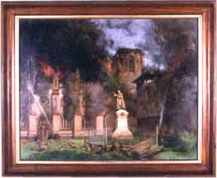
Amorsolo was able to capture on canvas the magnitude of the fire as well as the concerted effort of the firemen and the clergy to save the sanctuary. Noteworthy was his rendition of intensity of the fire through the application of hues, texture, and perspective, which were his trademarks. His early works such as this have a hyper-realistic style.
The original church structure, which was of gothic architecture, was previously located within Intramuros (Manila) and managed by the Dominican Order. It was one of the landmarks of Old Manila and frequented by devotees because of the alleged miraculous image of the Our Lady of the Most Holy Rosary (Nuestra Señora del Rosario de la Naval). The image is now enshrined in the new church located in Quezon Avenue, Quezon City.
One fine example of a historical painting, it depicts the destruction of the Sto. Domingo Church brought about by the tremendous fire that occurred in the 1940s.
Harana in Manila
1950s
Arturo R. Luz

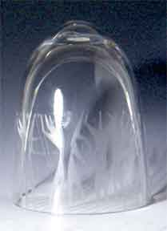
The Harana in Manila shows seven geometrical figures playing musical instru-ments and serenading the audience amidst fireworks (Fiesta time). The semi-concave glass medium is made by one of the leading glass manufacturers in the United States, the Steuben.
Although glass etching is not as popular as oil-on-canvas, art in glass reached its peak in the creation of stained glasses for churches and mausoleums. Contemporary visual artists contemplated of duplicating European techniques by using their ingenuity in transforming an ordinary glass into a work of art.
Arturo Luz, one of the leading contempo-rary painters, created an experimental art and captured in glass one of the highlights of Philippine tradition, the harana (serenade).
Mother and Child
1960s
Napoleon Abueva

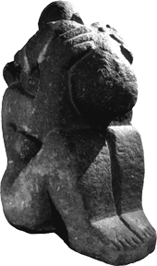

The huge art piece is sculpted from solid adobe and shows abstract figures of a woman in a sitting position and holding a child. The child, meanwhile, clings on the head of his mother.
The subject Mother and Child is very popular among visual artists. The National Museum prides itself with this Mother and Child sculpture created by Napoleon V. Abueva, a pioneer of Philippine modern sculpture.

Mother's Revenge
19th Century
Jose Rizal

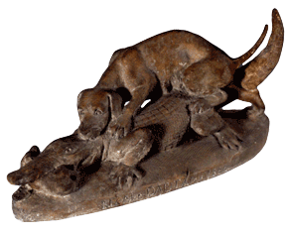
The sculpture in terra cotta (clay), Mother’s Revenge, is an allegorical representation of what was happening in the Philippines during that period. Shown is a mother dog trying to rescue her helpless pup from the bite of the crocodile. The mother dog represents “mother Philippines” and the patriots who are doing their best to save the defenseless countrymen - the pup - from the cruelty of the Spaniards as represented by the crocodile.
When Dr. Jose Rizal was exiled in Dapitan, Zamboanga, he made use of his artistic talent to create a piece that would symbolize the martyrdom and the exploitation of the indios by the colonizers. After more than 300 years of colonial rule, Rizal was the leading figure in the clamor for independence.

Coronation of the Virgin
18th Century

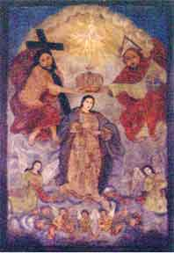
The painting depicts the Blessed Virgin Mary ceremoniously crowned by God the Father, God the Son, and God the Holy Spirit, in the form of a dove, as queen of heaven and earth.
The theme replicates the 5th Glorious Mystery of the Holy Rosary and the Litany. It is one of the oldest artwork in the visual arts collection. As a form of praise to the Blessed Virgin Mary, the theme is also used as a figure title, “Reyna de los Cielos”, in the traditional May-time festival, the Santacruzan.
An extremely rare icon belonging to the primitive school of Philippine art. It is typical of the religious art produced during the 18th century for household use (devotional piece).

La Descencion de Jesus
(The Descent of Jesus from the Cross)
1900s
Graciano T. Nepomuceno

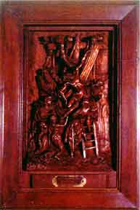

The artwork in hi-relief is an interpretation of Reuben’s oil-on-canvas original. It depicts the moment when Christ was taken down from the cross by Joseph of Arimathea in the presence of His disciples and Mother Mary. Noteworthy is the meticulous rendition of several figures with anatomical and dimensional precision.
The relief is an interpretation of the 13th Station of the Cross as found in all Roman Catholic Churches. The Stations of the Cross have been an educational forum for the Catholic Church to bring the Biblical events to the masses.
Graciano T. Nepomuceno was the leading sculptor and santero (icon maker) during the early 1900’s. He was the predecessor of Guillermo Tolentino, National Artist, in the University of the Philippines.

